**WEEK 3**

## Different Types of Computer Networks

There are various types of [Computer Networking](https://www.guru99.com/basic-computer-network.html) options available. The classification of network in computers can be done according to their size as well as their purpose.

The size of a network should be expressed by the geographic area and number of computers, which are a part of their networks. It includes devices housed in a single room to millions of devices spread across the world. Following are the popular types of Computer Network:

## [Types of Computer Networks](https://www.guru99.com/images/1/090719_0501_TypesofComp1.png)What is a LAN (Local Area Network)?

A **Local Area Network** (LAN) is a group of computer and peripheral devices which are connected in a limited area such as school, laboratory, home, and office building. It is a widely useful network for sharing resources like files, printers, games, and other application. The simplest type of LAN network is to connect computers and a printer in someone’s home or office. In general, LAN will be used as one type of transmission medium. It is a network which consists of less than 5000 interconnected devices across several buildings.

[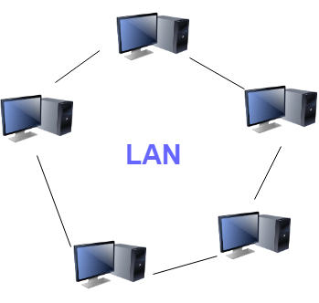](https://www.guru99.com/images/1/090719_0501_TypesofComp2.png)

Local Area Network (LAN)

### Characteristics of LAN

Here are the important characteristics of a LAN network:

* It is a private network, so an outside regulatory body never controls it.
* LAN operates at a relatively higher speed compared to other WAN systems.

### Advantages of LAN

Here are the pros/benefits of LAN:

* Computer resources like hard-disks, DVD-ROM, and printers can share local area networks. This significantly reduces the cost of hardware purchases.
* You can use the same software over the network instead of purchasing the licensed software for each client in the network.
* Data of all network users can be stored on a single hard disk of the server computer.
* You can easily transfer data and messages over networked computers.
* It will be easy to manage data at only one place, which makes data more secure.
* Local Area Network offers the facility to share a single internet connection among all the LAN users.

### Disadvantages of LAN

Here are the cons/drawbacks of LAN:

* LAN will indeed save cost because of shared computer resources, but the initial cost of installing Local Area Networks is quite high.
* The LAN admin can check personal data files of every LAN user, so it does not offer good privacy.

## What is WAN (Wide Area Network)?

**WAN** (Wide Area Network) is another important computer network that which is spread across a large geographical area. WAN network system could be a connection of a LAN which connects with other LAN’s using telephone lines and radio waves. It is mostly limited to an enterprise or an organization.

[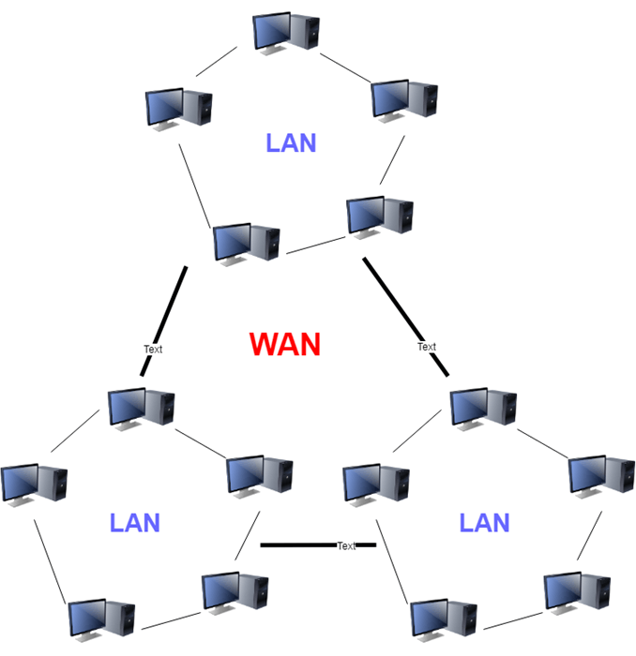](https://www.guru99.com/images/1/090719_0501_TypesofComp3.png)

Wide Area Network (WAN)

### Characteristics of WAN

Below are the characteristics of WAN:

* The software files will be shared among all the users; therefore, all can access to the latest files.
* Any organization can form its global integrated network using WAN.

### Advantages of WAN

Here are the benefits/pros of WAN:

* WAN helps you to cover a larger geographical area. Therefore business offices situated at longer distances can easily communicate.
* Contains devices like mobile phones, laptop, tablet, computers, gaming consoles, etc.
* WLAN connections work using radio transmitters and receivers built into client devices.

### Disadvantages of WAN

Here are the drawbacks/cons of WAN network:

* The initial setup cost of investment is very high.
* It is difficult to maintain the WAN network. You need skilled technicians and network administrators.
* There are more errors and issues because of the wide coverage and the use of different technologies.
* It requires more time to resolve issues because of the involvement of multiple wired and wireless technologies.
* Offers lower security compared to other types of network in computer.

**Also Check:** [LAN vs WAN: What’s the Difference?](https://www.guru99.com/lan-vs-wan.html)

## What is MAN (Metropolitan Area Network)?

A **Metropolitan Area Network** or MAN is consisting of a computer network across an entire city, college campus, or a small region. This type of network is large than a LAN, which is mostly limited to a single building or site. Depending upon the type of configuration, this type of network allows you to cover an area from several miles to tens of miles.

[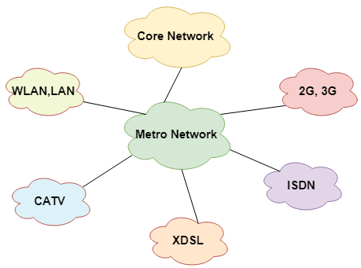](https://www.guru99.com/images/1/090719_0501_TypesofComp4.png)Metropolitan Area Network (MAN)

### Characteristics of MAN

Here are important characteristics of the MAN network:

* It mostly covers towns and cities in a maximum 50 km range
* Mostly used medium is optical fibers, cables
* Data rates adequate for distributed computing applications.

### Advantages of MAN

Here are the pros/benefits of MAN network:

* It offers fast communication using high-speed carriers, like [fiber optic cables](https://www.guru99.com/ethernet-cables-types.html).
* It provides excellent support for an extensive size network and greater access to WANs.
* The dual bus in MAN network provides support to transmit data in both directions concurrently.
* A MAN network mostly includes some areas of a city or an entire city.

### Disadvantages of MAN

Here are drawbacks/cons of using the MAN network:

* You need more cable to establish MAN connection from one place to another.
* In MAN network it is tough to make the system secure from hackers

**Layers of OSI Model**

OSI stands for **Open Systems Interconnection**. It has been developed by ISO – ‘**International Organization for Standardization**‘, in the year 1984. It is a 7-layer architecture with each layer having specific functionality to perform. All these 7 layers work collaboratively to transmit the data from one person to another across the globe.

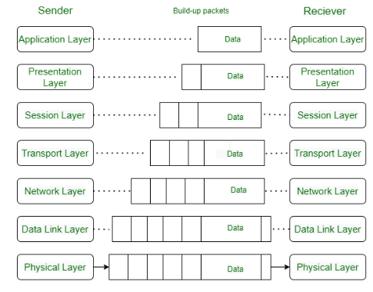

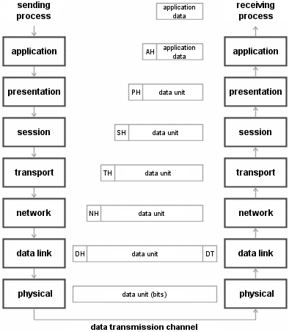

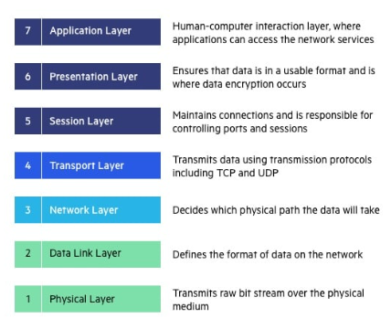

## Layers of OSI Model

1. [Physical Layer](https://www.geeksforgeeks.org/physical-layer-in-osi-model/)
2. [Data Link Layer](https://www.geeksforgeeks.org/data-link-layer/)
3. [Network Layer](https://www.geeksforgeeks.org/network-layer-services-packetizing-routing-and-forwarding/)
4. [Transport Layer](https://www.geeksforgeeks.org/transport-layer-responsibilities/)
5. [Session Layer](https://www.geeksforgeeks.org/session-layer-in-osi-model/)
6. [Presentation Layer](https://www.geeksforgeeks.org/presentation-layer-in-osi-model/)
7. [Application Layer](https://www.geeksforgeeks.org/application-layer-in-osi-model/)

## ****Layer 1- Physical Layer****

The lowest layer of the OSI reference model is the physical layer. It is responsible for the actual physical connection between the devices. The physical layer contains information in the form of**bits.** It is responsible for transmitting individual bits from one node to the next. When receiving data, this layer will get the signal received and convert it into 0s and 1s and send them to the Data Link layer, which will put the frame back together.

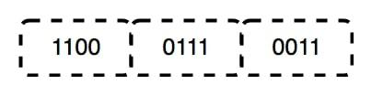

*Data Bits in the Physical Layer*

### The Functions of the Physical Layer

* **Bit synchronization:** The physical layer provides the synchronization of the bits by providing a clock. This clock controls both sender and receiver thus providing synchronization at the bit level.
* **Bit rate control:** The Physical layer also defines the transmission rate i.e. the number of bits sent per second.
* **Physical topologies:** Physical layer specifies how the different, devices/nodes are arranged in a network i.e. bus, star, or mesh topology.
* **Transmission mode:** Physical layer also defines how the data flows between the two connected devices. The various transmission modes possible are Simplex, half-duplex and full-duplex.

**Note:** 1. Hub, Repeater, Modem, and Cables are Physical Layer devices.

             2. Network Layer, Data Link Layer, and Physical Layer are also known as **Lower Layers** or **Hardware Layers**.

## ****Layer 2- Data Link Layer (DLL)****

The data link layer is responsible for the node-to-node delivery of the message. The main function of this layer is to make sure data transfer is error-free from one node to another, over the physical layer. When a packet arrives in a network, it is the responsibility of the DLL to transmit it to the Host using its MAC address.   
The Data Link Layer is divided into two sublayers:

1. [Logical Link Control (LLC)](https://www.geeksforgeeks.org/logical-link-control-llc-protocol-data-unit/)
2. [Media Access Control (MAC)](https://www.geeksforgeeks.org/introduction-of-mac-address-in-computer-network/)

The packet received from the Network layer is further divided into frames depending on the frame size of the NIC(Network Interface Card). DLL also encapsulates Sender and Receiver’s MAC address in the header.

The Receiver’s MAC address is obtained by placing an [ARP(Address Resolution Protocol)](https://www.geeksforgeeks.org/how-address-resolution-protocol-arp-works/)request onto the wire asking “Who has that IP address?” and the destination host will reply with its MAC address.

### The Functions of the Data Link Layer

* **Framing:**Framing is a function of the data link layer. It provides a way for a sender to transmit a set of bits that are meaningful to the receiver. This can be accomplished by attaching special bit patterns to the beginning and end of the frame.
* **Physical addressing:** After creating frames, the Data link layer adds physical addresses (MAC addresses) of the sender and/or receiver in the header of each frame.
* **Error control:** The data link layer provides the mechanism of error control in which it detects and retransmits damaged or lost frames.
* **Flow Control:** The data rate must be constant on both sides else the data may get corrupted thus, flow control coordinates the amount of data that can be sent before receiving an acknowledgment.
* **Access control:**When a single communication channel is shared by multiple devices, the MAC sub-layer of the data link layer helps to determine which device has control over the channel at a given time.

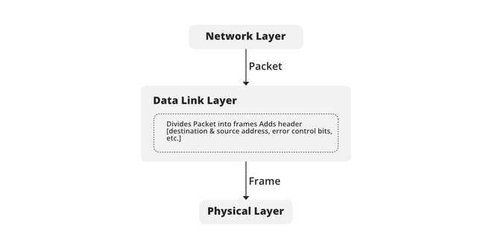

*Function of DLL*

**Note:**1. Packet in the Data Link layer is referred to as **Frame.**

           2. Data Link layer is handled by the NIC (Network Interface Card) and device drivers of host machines.

           3. Switch & Bridge are Data Link Layer devices.

## ****Layer 3- Network Layer****

The network layer works for the transmission of data from one host to the other located in different networks. It also takes care of packet routing i.e. selection of the shortest path to transmit the packet, from the number of routes available. The sender & receiver’s IP addresses are placed in the header by the network layer.

### The Functions of the Network Layer

* **Routing:** The network layer protocols determine which route is suitable from source to destination. This function of the network layer is known as routing.
* **Logical Addressing:**To identify each device on Internetwork uniquely, the network layer defines an addressing scheme. The sender & receiver’s IP addresses are placed in the header by the network layer. Such an address distinguishes each device uniquely and universally.

Note: 1. Segment in the Network layer is referred to as **Packet**.

          2. Network layer is implemented by networking devices such as routers and switches.

## ****Layer 4- Transport Layer****

The transport layer provides services to the application layer and takes services from the network layer. The data in the transport layer is referred to as Segments. It is responsible for the End to End Delivery of the complete message. The transport layer also provides the acknowledgment of the successful data transmission and re-transmits the data if an error is found.

**At the sender’s side:**The transport layer receives the formatted data from the upper layers, performs **Segmentation**, and also implements **Flow & Error control** to ensure proper data transmission. It also adds Source and Destination port numbers in its header and forwards the segmented data to the Network Layer.

**Note:** The sender needs to know the port number associated with the receiver’s application.

Generally, this destination port number is configured, either by default or manually. For example, when a web application requests a web server, it typically uses port number 80, because this is the default port assigned to web applications. Many applications have default ports assigned.

**At the receiver’s side:** Transport Layer reads the port number from its header and forwards the Data which it has received to the respective application. It also performs sequencing and reassembling of the segmented data.

### The Functions of the Transport Layer

* **Segmentation and Reassembly:** This layer accepts the message from the (session) layer, and breaks the message into smaller units. Each of the segments produced has a header associated with it. The transport layer at the destination station reassembles the message.
* **Service Point Addressing:** To deliver the message to the correct process, the transport layer header includes a type of address called service point address or port address. Thus by specifying this address, the transport layer makes sure that the message is delivered to the correct process.

#### Services Provided by Transport Layer

1. [Connection-Oriented Service](https://www.geeksforgeeks.org/connection-oriented-service/)
2. [Connectionless Service](https://www.geeksforgeeks.org/connection-less-service/)

**1. Connection-Oriented Service:** It is a three-phase process that includes

* Connection Establishment
* Data Transfer
* Termination/disconnection

In this type of transmission, the receiving device sends an acknowledgment, back to the source after a packet or group of packets is received. This type of transmission is reliable and secure.

**2. Connectionless service:** It is a one-phase process and includes Data Transfer. In this type of transmission, the receiver does not acknowledge receipt of a packet. This approach allows for much faster communication between devices. Connection-oriented service is more reliable than connectionless Service.

**Note:**  1. Data in the Transport Layer is called **Segments**.

           2. Transport layer is operated by the Operating System. It is a part of the OS and communicates with the Application Layer by making system calls.   
           3. The transport layer is called as **Heart of the OSI** model.

           4. **Device or Protocol Use :** TCP, UDP  NetBIOS, PPTP

## ****Layer 5- Session Layer****

This layer is responsible for the establishment of connection, maintenance of sessions, and authentication, and also ensures security.

### The Functions of the Session Layer

* **Session establishment, maintenance, and termination:** The layer allows the two processes to establish, use and terminate a connection.
* **Synchronization:** This layer allows a process to add checkpoints that are considered synchronization points in the data. These synchronization points help to identify the error so that the data is re-synchronized properly, and ends of the messages are not cut prematurely and data loss is avoided.
* **Dialog Controller:** The session layer allows two systems to start communication with each other in half-duplex or full-duplex.

**Note:** 1. All the below 3 layers(including Session Layer) are integrated as a single layer in the TCP/IP model as the “Application Layer”.

           2. Implementation of these 3 layers is done by the network application itself. These are also known as **Upper Layers or** **Software Layers.**

           3. **Device or Protocol Use :**  NetBIOS, PPTP

#### Scenario

Let us consider a scenario where a user wants to send a message through some Messenger application running in his browser. The “Messenger” here acts as the application layer which provides the user with an interface to create the data. This message or so-called Data is compressed, encrypted (if any secure data), and converted into bits (0’s and 1’s) so that it can be transmitted.

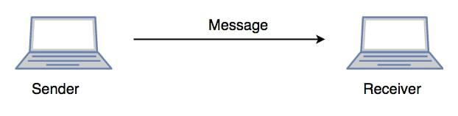

*Communication in Session Layer*

## ****Layer 6- Presentation Layer****

The presentation layer is also called the **Translation layer**. The data from the application layer is extracted here and manipulated as per the required format to transmit over the network.

### The Functions of the Presentation Layer are

* **Translation:** For example, ASCII to EBCDIC.
* **Encryption/ Decryption:** Data encryption translates the data into another form or code. The encrypted data is known as the ciphertext and the decrypted data is known as plain text. A key value is used for encrypting as well as decrypting data.
* **Compression:** Reduces the number of bits that need to be transmitted on the network.

Note: **Device or Protocol Use :**  JPEG, MPEG, GIF

## ****Layer 7- Application Layer****

At the very top of the OSI Reference Model stack of layers, we find the Application layer which is implemented by the network applications. These applications produce the data, which has to be transferred over the network. This layer also serves as a window for the application services to access the network and for displaying the received information to the user.

Example: Application – Browsers, Skype Messenger, etc.

**Note:** 1. The application Layer is also called Desktop Layer.

2.**Device or Protocol Use :**  SMTP

### The Functions of the Application Layer are

* Network Virtual Terminal: It allows a user to log on to a remote host.
* FTAM- File transfer access and management : This application allows a user to  
  access file in a remote host, retrieve files in remote host and manage or  
  control files from a remote computer.
* Mail Services : Provide email service.
* Directory Services : This application provides distributed database sources  
  and access for global information about various objects and services.

**OSI model** acts as a reference model and is not implemented on the Internet because of its late invention. The current model being used is the TCP/IP model.